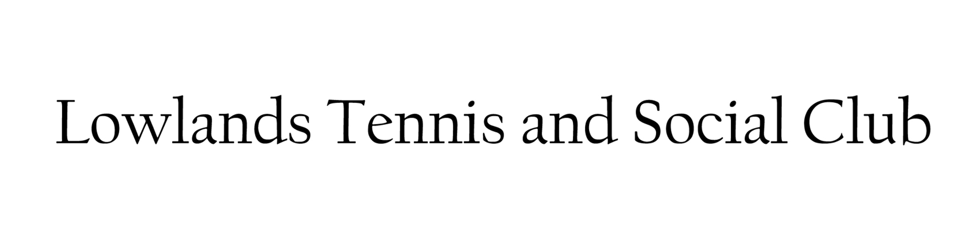

Lowlands Road, Eastcote, Middlesex HA5 1TU [www.lowlandsclub.com](http://www.lowlandsclub.com)

**APPLICATION FOR MEMBERSHIP**

**(one form per member)**

|  |  |
| --- | --- |
| NAME: inc title *(block capitals)* | Click or tap here to enter text. |
| ADDRESS: inc Post Code | Click or tap here to enter text. |
| TELEPHONE NO: | Click or tap here to enter text. |
| EMAIL: (*please write legibly*) | Click or tap here to enter text. |
| DATE OF BIRTH: | Click or tap here to enter text. |
| NAME & CONTACT DETAILS OF PARENT/GUARDIAN *(if under 16yrs)* | Click or tap here to enter text. |

**PLEASE TICK ONE:**

|  |  |  |  |
| --- | --- | --- | --- |
| **ADULT TENNIS:**  *(Affiliated to Middx LTA)* | Full Tennis | Intermediate Tennis | Social Tennis |
| ***Note: For Junior Tennis Membership see Junior Tennis Member Application Form*** | | | |
| **TABLE TENNIS:** *(Team/League Players Only)*  *Members of**Wembley and Harrow Table Tennis League* | | **SOCIAL:**  *(Inc social Table Tennis and Snooker)* | |

***NOTE: ALL TENNIS AND TABLE TENNIS MEMBERS ARE AUTOMATICALLY SOCIAL MEMBERS.***

|  |  |
| --- | --- |
| **HEALTH DECLARATION** |  |
| I confirm that I am fit to take part in all club activities and have not been advised otherwise by a GP or Hospital Doctor***.*** |  |
| Contact Name & Phone Number in the Event of an Emergency: |  |

|  |  |
| --- | --- |
| **PRIVACY POLICY (GDPR) – see website (www.lowlandsclub.com)** |  |
| By submitting your personal information to us and ticking the acceptance box on this application form, you signify in a pro-active way, your consent to our using the information for purposes outlined in the Privacy (GDPR) policy available from our website. If at any time you wish to update the information held or you wish to stop receiving information from the club, please contact the club at info@lowlandsclub.com. |  |

|  |  |
| --- | --- |
| **CLUB RULES, POLICIES & PROCEDURES – see website (www.lowlandsclub.com)** |  |
| I have read, understood, and agree to abide by, the Club Rules and Regulations – see website. |  |

|  |  |
| --- | --- |
| **PHOTOGRAPHY** |  |
| I agree to the possibility of having my/our photo taken at Club events and that these photos may be used to promote the club on Social Media such as the Club’s Facebook page. |  |

*By signing this form, you agree to become a member of Lowlands Club and abide by the Club’s Rules, Policies & Procedures.*

|  |  |  |  |
| --- | --- | --- | --- |
| **Signature:** |  | **Date:** |  |

|  |
| --- |
| **Completed Forms should be returned to the Membership Secretary at info@lowlandsclub.com.**  **Forms may also be placed in the club post box (to the left of the front door) or left at the bar when open.** |

Feb 2025